**How to install Oracle SQL Developer**

**1. Oracle Database**



**2. Java SDK**

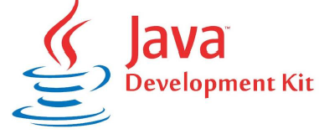

**3. Oracle SQL Developer**

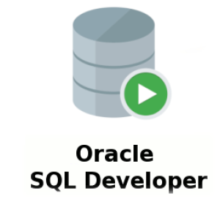

**1. Oracle Database**

Download: Go to this link: [www.oracle.com](http://www.oracle.com)

Download>Database> Database 18c Express Edition> Windows 64/32

1.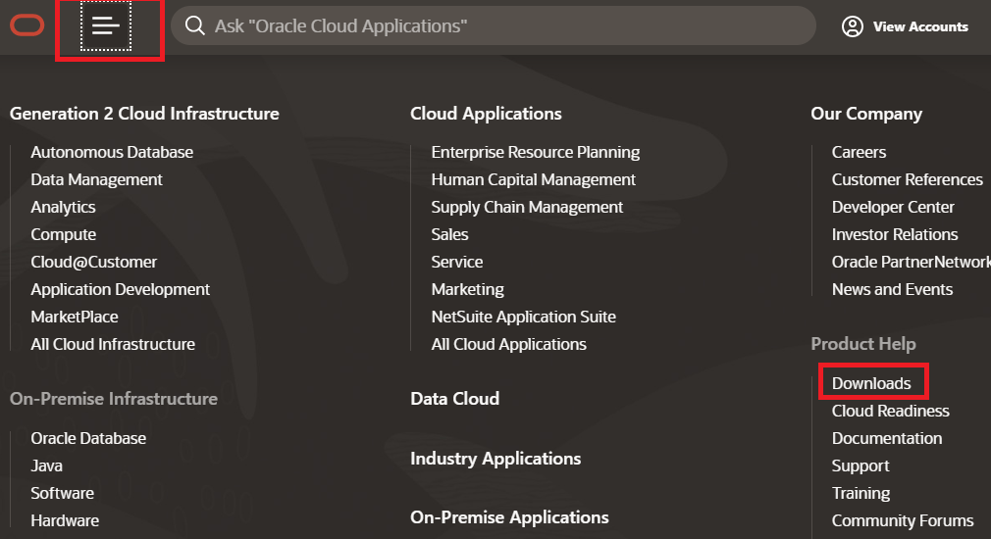

2.

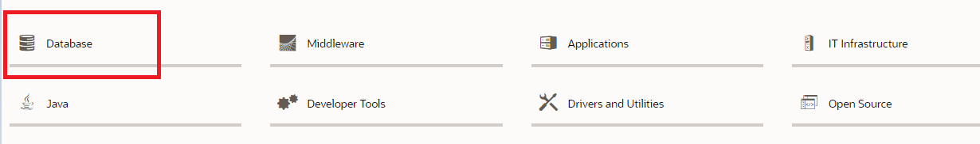

3.

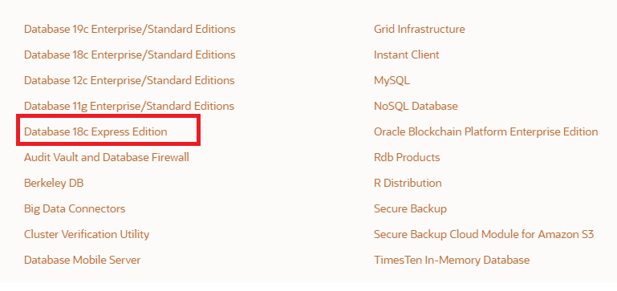

**4.**



**5.**

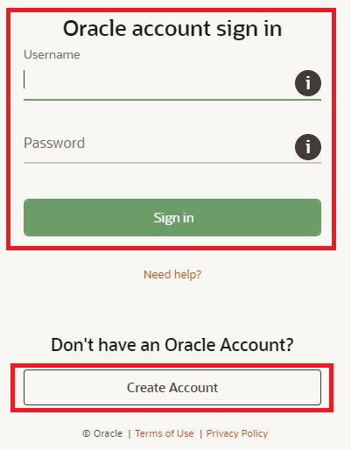

**6.**

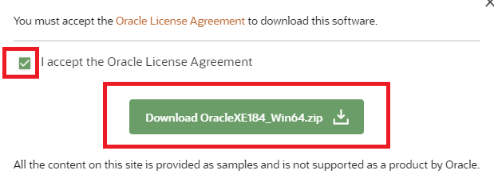

**Installation**

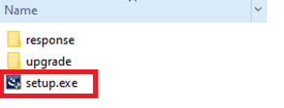

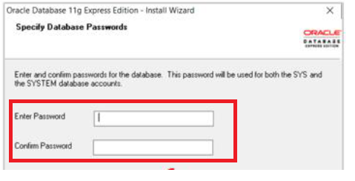

Make sure you remember the password you entered

**2. Java SDK**

Download: Go to this link: [www.oracle.com](http://www.oracle.com)

Download: Download>Java> Java se> Java SE 8u241

1.

2.

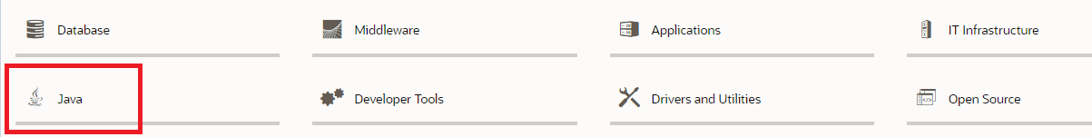

3.

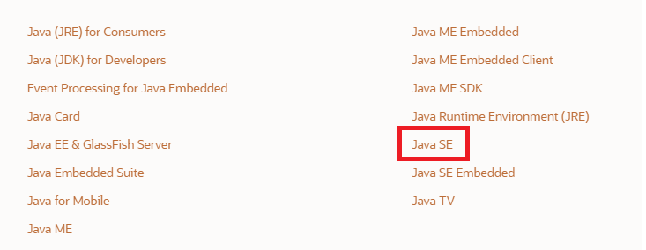

4.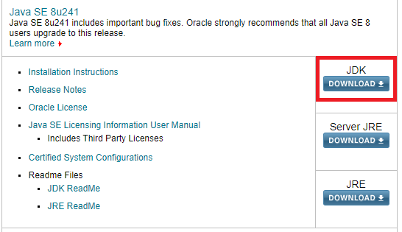

5.

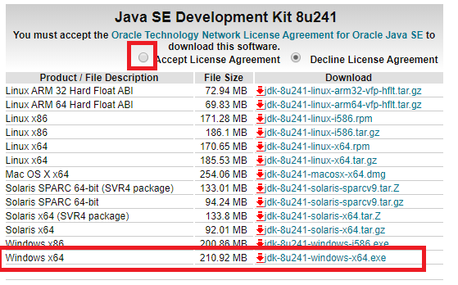

**Installation**



Remember this path when installing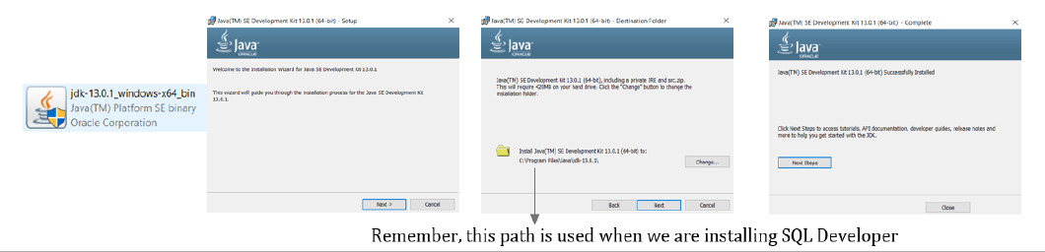

**3. Oracle SQL Developer**

Download: Go to this link: [www.oracle.com](http://www.oracle.com)

Download>Developer tools> SQL Developer > Windows 32-bit/64-bit

1.

2.

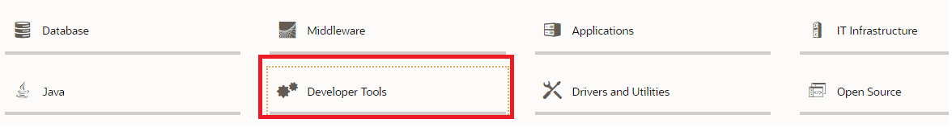

3.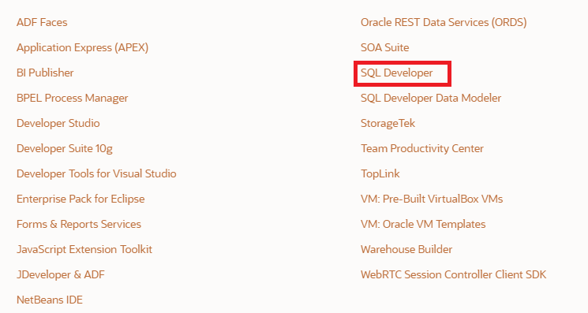

4.

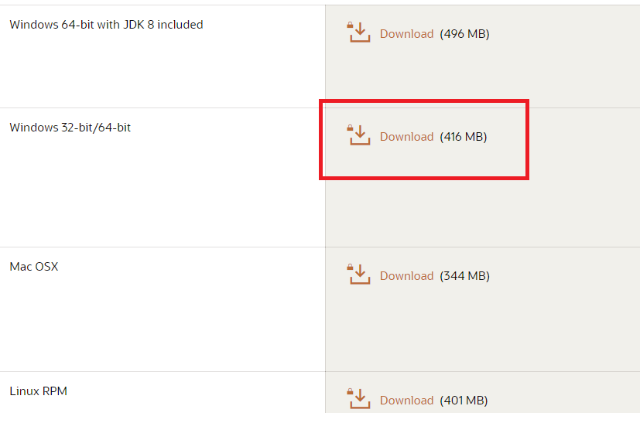

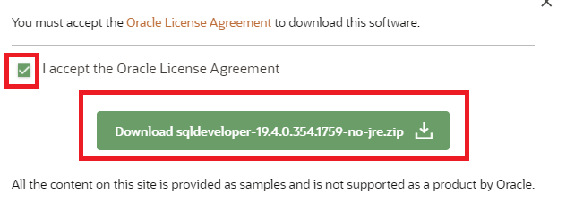

**Installation**

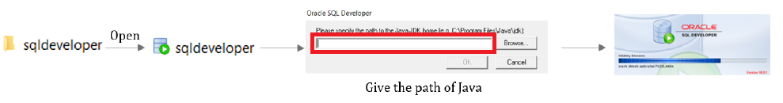

**Home Page of Oracle SQL Developer**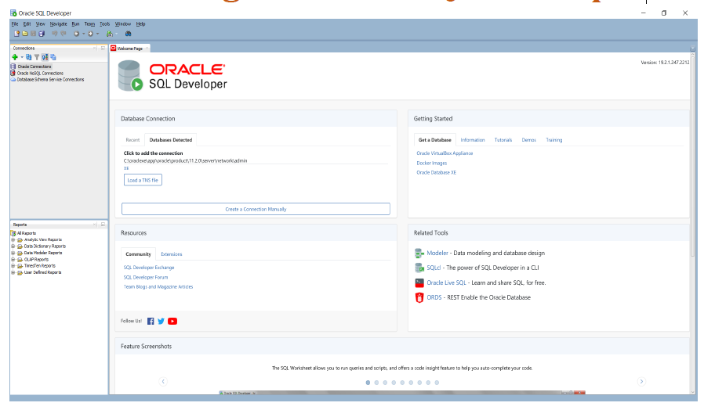

**Oracle SQL Developer - Create Shortcut to Desktop**

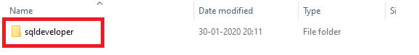

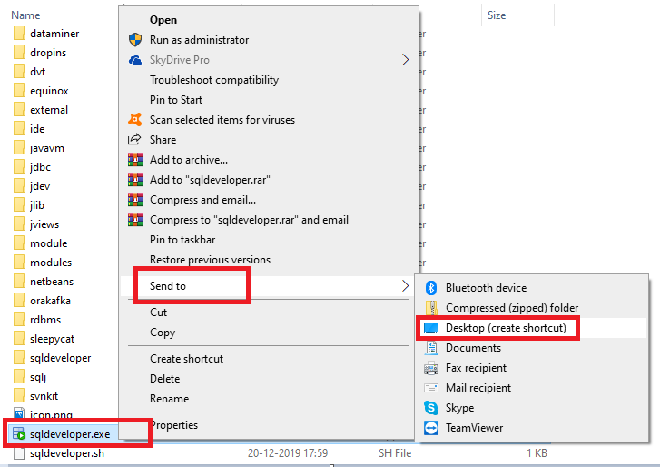

**Set up your Oracle Connection 1st time**

